LP-1 SPOS LA3
Neeti Kurulkar
Write a program to simulate CPU Scheduling Algorithms: FCFS, SJF (Preemptive), Priority (Non-Preemptive) and Round Robin (Preemptive).

- FCFS:
import java.util.*;

class Process {
String id;
int arrival_time;
int burst_time;
int completion_time;
int turn_around_time;
int waiting_time;

Process() {}

Process(String pid, int ar, int br) {
id = pid;
arrival_time = ar;
burst_time = br;
}
}

public class Main {
public static void main(String[] args) {
Scanner sc = new Scanner(System.in);

System.out.print("Enter Number of Processes: ");
int n = sc.nextInt();

Process[] process_queue = new Process[n];
Process temp = new Process();
String pid;
int ar, br;
float avgwt = 0, avgtat = 0;

for (int i = 0; i < n; i++) {
System.out.print("Enter Arrival Time for Process " + (i + 1) + ": ");
ar = sc.nextInt();
System.out.print("Enter Burst Time for Process " + (i + 1) + ": ");
br = sc.nextInt();
process_queue[i] = new Process(("p" + (i+1)), ar, br);
}

// Sorting based on arrival time
for (int i = 0; i < n; i++) {
for (int j = 0; j < (n - i - 1); j++) {
if (process_queue[j].arrival_time > process_queue[j + 1].arrival_time) {
temp = process_queue[j];
process_queue[j] = process_queue[j + 1];
process_queue[j + 1] = temp;
}
}
}

// Calculating completion, turnaround, and waiting times
for (int i = 0; i < n; i++) {
if (i == 0) {
process_queue[i].completion_time = process_queue[i].arrival_time + process_queue[i].burst_time;
} else {
if (process_queue[i].arrival_time > process_queue[i - 1].completion_time) {
process_queue[i].completion_time = process_queue[i].arrival_time + process_queue[i].burst_time;
} else {
process_queue[i].completion_time = process_queue[i - 1].completion_time + process_queue[i].burst_time;
}
}
process_queue[i].turn_around_time = process_queue[i].completion_time - process_queue[i].arrival_time;
process_queue[i].waiting_time = process_queue[i].turn_around_time - process_queue[i].burst_time;

avgwt += process_queue[i].waiting_time;
avgtat += process_queue[i].turn_around_time;
}

// Display the process details
System.out.println("--------------------------------------------------------------------");
System.out.println("Process\t\tArrival Time\tBurst Time\tCompletion Time\tTurnaround Time\tWaiting Time");
System.out.println("--------------------------------------------------------------------");
for (int i = 0; i < n; i++) {
System.out.println(process_queue[i].id + "\t\t" + process_queue[i].arrival_time + "\t\t" + process_queue[i].burst_time + "\t\t" + process_queue[i].completion_time + "\t\t" + process_queue[i].turn_around_time + "\t\t" + process_queue[i].waiting_time);
}

// Display average waiting and turnaround times
System.out.println("Average Waiting Time = " + (avgwt / n));
System.out.println("Average Turn Around Time = " + (avgtat / n));

sc.close();
}
}

Output:
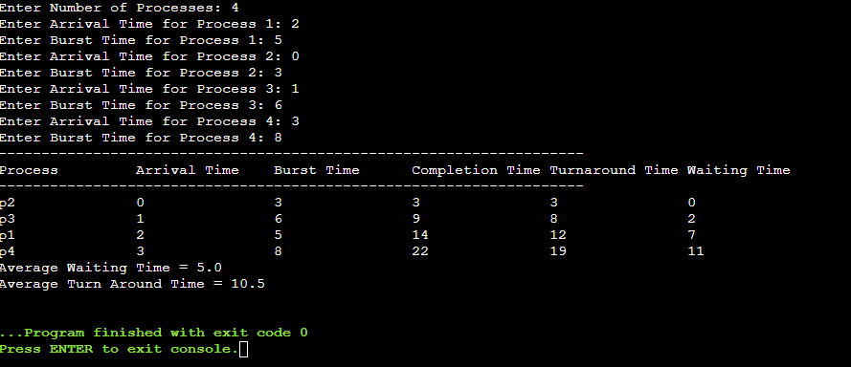

- SJF (Preemptive):

import java.util.Scanner;

class Process {
String id;
int arrival_time;
int burst_time;
int completion_time;
int turn_around_time;
int waiting_time;
int remaining_time;
boolean isCompleted;

Process(String pid, int ar, int br) {
id = pid;
arrival_time = ar;
burst_time = br;
remaining_time = br;
isCompleted = false;
}
}

public class Main {
public static void main(String[] args) {
Scanner sc = new Scanner(System.in);

System.out.print("Enter number of processes: ");
int n = sc.nextInt();
Process[] process_queue = new Process[n];
int total_completed = 0, current_time = 0;
float avgwt = 0, avgtat = 0;

for (int i = 0; i < n; i++) {
System.out.print("Enter Arrival Time for Process " + (i + 1) + ": ");
int ar = sc.nextInt();
System.out.print("Enter Burst Time for Process " + (i + 1) + ": ");
int br = sc.nextInt();
process_queue[i] = new Process(("p" + (i+1)), ar, br);
}

while (total_completed < n) {
int min_burst_index = n;
int min_burst_time = Integer.MAX_VALUE;

// Find the process with the minimum remaining burst time that has arrived
for (int i = 0; i < n; i++) {
if (process_queue[i].arrival_time <= current_time &&
!process_queue[i].isCompleted &&
process_queue[i].remaining_time < min_burst_time) {
min_burst_time = process_queue[i].remaining_time;
min_burst_index = i;
}
}

if (min_burst_index == n) {
current_time++;
} else {
process_queue[min_burst_index].remaining_time--;
current_time++;

if (process_queue[min_burst_index].remaining_time == 0) {
process_queue[min_burst_index].completion_time = current_time;
process_queue[min_burst_index].turn_around_time =
process_queue[min_burst_index].completion_time -
process_queue[min_burst_index].arrival_time;
process_queue[min_burst_index].waiting_time =
process_queue[min_burst_index].turn_around_time -
process_queue[min_burst_index].burst_time;
process_queue[min_burst_index].isCompleted = true;
total_completed++;

avgwt += process_queue[min_burst_index].waiting_time;
avgtat += process_queue[min_burst_index].turn_around_time;
}
}
}

System.out.println("--------------------------------------------------------------------------");
System.out.println("Process\t\tArrival Time\tBurst Time\tCompletion Time\tTurnaround Time\tWaiting Time");
System.out.println("--------------------------------------------------------------------------");

for (int i = 0; i < n; i++) {
System.out.println(process_queue[i].id + "\t\t" +
process_queue[i].arrival_time + "\t\t" +
process_queue[i].burst_time + "\t\t" +
process_queue[i].completion_time + "\t\t" +
process_queue[i].turn_around_time + "\t\t" +
process_queue[i].waiting_time);
}

System.out.println("\nAverage Turn Around Time: " + (avgtat / n));
System.out.println("Average Waiting Time: " + (avgwt / n));

sc.close();
}
}

Output:

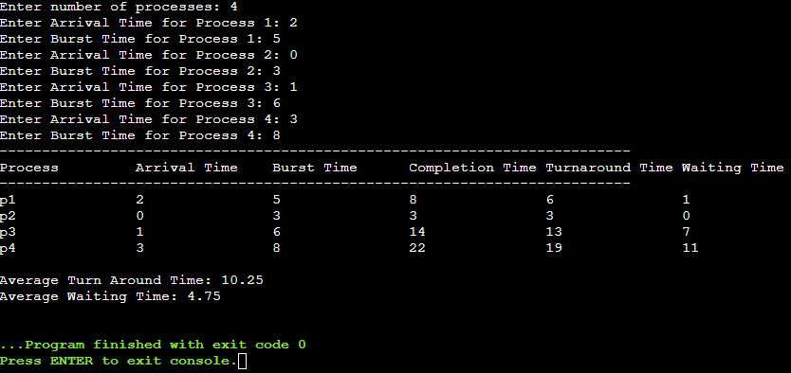

- Round Robin:

import java.util.Scanner;

class Process {
String id;
int arrival_time;
int burst_time;
int remaining_bt;
int completion_time;
int turnaround_time;
int waiting_time;
boolean is_completed;

Process(String pid, int at, int bt) {
id = pid;
arrival_time = at;
burst_time = bt;
remaining_bt = bt; // Remaining burst time is initially equal to burst time
is_completed = false;
}
}

public class Main {
public static void main(String[] args) {
Scanner sc = new Scanner(System.in);

System.out.print("Enter the number of processes (maximum 10): ");
int n = sc.nextInt();
Process[] process_queue = new Process[n];

System.out.println("Enter the Arrival Time and Burst Time for each process:");
for (int i = 0; i < n; i++) {
System.out.print("P" + (i + 1) + " (Arrival Time): ");
int at = sc.nextInt();
System.out.print("P" + (i + 1) + " (Burst Time): ");
int bt = sc.nextInt();
process_queue[i] = new Process("P" + (i + 1), at, bt);
}

System.out.print("Enter the quantum time: ");
int quantum_time = sc.nextInt();

// Sort processes by arrival time using Bubble Sort
for (int i = 0; i < n - 1; i++) {
for (int j = 0; j < n - i - 1; j++) {
if (process_queue[j].arrival_time > process_queue[j + 1].arrival_time) {
Process temp = process_queue[j];
process_queue[j] = process_queue[j + 1];
process_queue[j + 1] = temp;
}
}
}

// Initialize variables
int current_time = 0; // Tracks the current time
int completed = 0; // Number of completed processes
int total_tat = 0, total_wt = 0; // Total Turnaround Time and Waiting Time

// Process execution using Round Robin
while (completed < n) {
boolean process_executed = false;

for (int i = 0; i < n; i++) {
Process p = process_queue[i];

// Process can execute only if it's arrived and not yet completed
if (p.arrival_time <= current_time && !p.is_completed) {
process_executed = true;

// If remaining burst time is more than quantum time, execute for quantum time
if (p.remaining_bt > quantum_time) {
current_time += quantum_time;
p.remaining_bt -= quantum_time;
} else {
// Process completes in this round
current_time += p.remaining_bt;
p.remaining_bt = 0;
p.completion_time = current_time;

// Calculate turnaround time and waiting time
p.turnaround_time = p.completion_time - p.arrival_time;
p.waiting_time = p.turnaround_time - p.burst_time;

total_tat += p.turnaround_time;
total_wt += p.waiting_time;

p.is_completed = true; // Mark process as completed
completed++;
}
}
}

// If no process was executed, advance time to the next arriving process
if (!process_executed) {
current_time++;
}
}

// Display process information
System.out.println("------------------------------------------------------------------------------------");
System.out.println("Process\t\tArrival Time\tBurst Time\tCompletion Time\tTurnaround Time\tWaiting Time");
System.out.println("------------------------------------------------------------------------------------");

for (int i = 0; i < n; i++) {
Process p = process_queue[i];
System.out.println(p.id + "\t\t" + p.arrival_time + "\t\t" + p.burst_time + "\t\t" +
p.completion_time + "\t\t" + p.turnaround_time + "\t\t" + p.waiting_time);
}

// Calculate and display average turnaround time and waiting time
System.out.println("\nAverage Turnaround Time = " + (float) total_tat / n);
System.out.println("Average Waiting Time = " + (float) total_wt / n);

sc.close();
}
}

Output:
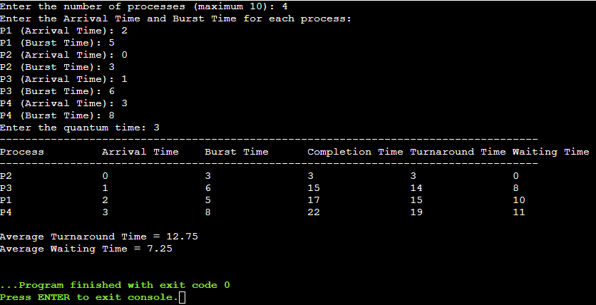

- Priority (non-preemptive):

import java.util.*;

class Process {
String id;
int arrival_time;
int burst_time;
int priority;
int completion_time;
int turn_around_time;
int waiting_time;
boolean isCompleted = false;

Process(String pid, int ar, int br, int pr) {
id = pid;
arrival_time = ar;
burst_time = br;
priority = pr;
}
}

public class Main {
public static void main(String[] args) {
Scanner sc = new Scanner(System.in);

System.out.print("Enter Number of Processes: ");
int n = sc.nextInt();
Process[] process_queue = new Process[n];

for (int i = 0; i < n; i++) {
System.out.print("Enter Arrival Time for Process " + (i + 1) + " : ");
int ar = sc.nextInt();
System.out.print("Enter Burst Time for Process " + (i + 1) + " : ");
int br = sc.nextInt();
System.out.print("Enter Priority for Process " + (i + 1) + " : ");
int pr = sc.nextInt();
process_queue[i] = new Process(("p" + (i+1)), ar, br, pr);
}

// Sort processes based on arrival time
Arrays.sort(process_queue, Comparator.comparingInt(p -> p.arrival_time));

int currentTime = 0;
int completedProcesses = 0;
float total_tat = 0, total_wt = 0;

// Continue until all processes are completed
while (completedProcesses < n) {
// Find process with highest priority from arrived processes
Process currentProcess = null;
int highestPriority = Integer.MAX_VALUE;

for (Process p : process_queue) {
if (!p.isCompleted && p.arrival_time <= currentTime && p.priority < highestPriority) {
highestPriority = p.priority;
currentProcess = p;
}
}

if (currentProcess != null) {
// Process found, execute it
currentProcess.completion_time = currentTime + currentProcess.burst_time;
currentProcess.turn_around_time = currentProcess.completion_time - currentProcess.arrival_time;
currentProcess.waiting_time = currentProcess.turn_around_time - currentProcess.burst_time;

total_tat += currentProcess.turn_around_time;
total_wt += currentProcess.waiting_time;

currentProcess.isCompleted = true;
completedProcesses++;
currentTime = currentProcess.completion_time;
} else {
// If no process is ready, increment time
currentTime++;
}
}

// Print process details
System.out.println("------------------------------------------------------------------------------------------------------");
System.out.println("Process\t\tArrival Time\tBurst Time\tCompletion Time\tTurnaround Time\tWaiting Time");
System.out.println("------------------------------------------------------------------------------------------------------");

for (int i = 0; i < n; i++) {
System.out.println(process_queue[i].id + "\t\t" + process_queue[i].arrival_time + "\t\t\t" +
process_queue[i].burst_time + "\t\t\t" + process_queue[i].completion_time + "\t\t\t" +
process_queue[i].turn_around_time + "\t\t\t" + process_queue[i].waiting_time);
}

System.out.println("\nAverage Waiting Time = " + (total_wt / n));
System.out.println("Average Turn Around Time = " + (total_tat / n));

sc.close();
}
}

Output:

